**SpeakEZ**

**AI Language Translator**

**User Manual**

Table of Contents

**Introduction** **3**

**Getting Started** **4**

**Creating an Account** **5**

I. Logging into Your Account 5

II. Creating an Account 6

**Navigation** **7**

I. Drag and Drop or Browse 7

II. Audio Icon 8

III. Remove File 9

IV. Language Selection 9

V. Transcribe 10

VI. Translate 10

VII. History 11

VIII. Clear History 11

IX. Favorite 12

X. Remove Favorite 12

XI. Help Icon 13

XII. Dark Mode 13

XIII. Logout 14

XIV. SpeakEZ Icon 14

# Introduction

Welcome to the User Manual for the SpeakEZ AI-integrated web application. This document is designed to give you a step-by-step guide to using our application. SpeakEZ allows users of different language backgrounds to communicate with each other seamlessly. By bridging the communication gap between users, users can share ideas, information, and foster global understanding between each other.

# Getting Started

Before using the SpeakEZ AI Language Translator, we recommend you create an account with us to be able to access premium features such as history and favorites. The following steps will guide you on how to get started with us.

# Creating an Account

## Logging into Your Account

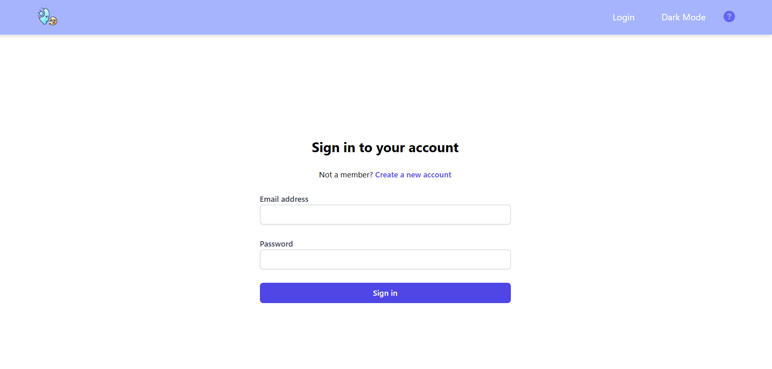

1. When you first access our page, you will be directed to the “Sign in” page.
2. Please sign in with a valid Email Address and Password.
3. Select the “Sign in” button below.

## Creating an Account

If you do not already have an account with us, please click “Create a new account” on the “Sign In” page to do so.

1. When you click “Create a new account,” you should be directed to the page above. Please fill out the required fields with a valid Name, Email Address, and Password. 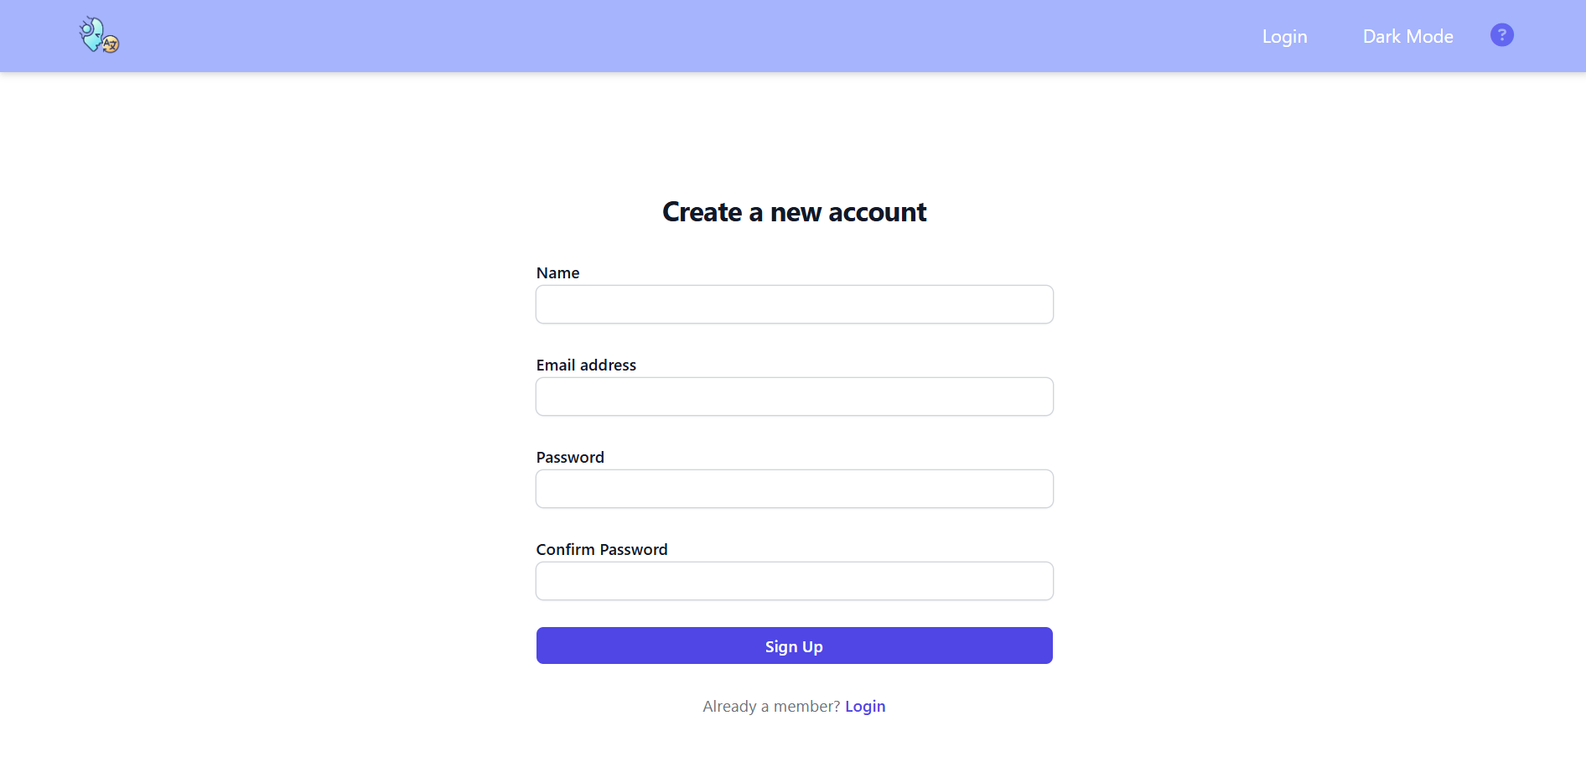
2. Once you have filled in all of the required fields and clicked “Sign Up”, you should be redirected to the “Sign In” page where you will fill out the fields with the information you used to create an account with us.

# Navigation

Once you have logged in with your login information, you will be directed to the main Translation page. The following steps will guide you on navigating this page.

## Drag and Drop or Browse

[view gif](https://github.com/htmw/2024F-Bytes/raw/main/Images/drag.gif)

1. You can upload a .mp3 audio file by simply dragging the file into the designated box as shown in the gif above. Once you have successfully uploaded the file, you will see the filename appear below.



[view gif](https://github.com/htmw/2024F-Bytes/raw/main/Images/browse.gif)

1. You can also upload an audio file by selecting “browse.” When you select “browse,” your file explorer will open and allow you to select any file of a .mp3 format. Once you have successfully uploaded the file, you will see the filename appear below.

## Audio Icon

[view gif](https://github.com/htmw/2024F-Bytes/raw/main/Images/audio_icon.gif)

1. You can record audio using our application by clicking the Audio Icon. Once you click the audio icon, the icon will then turn red to indicate a stop button. To stop recording please press the stop button.

## Remove File

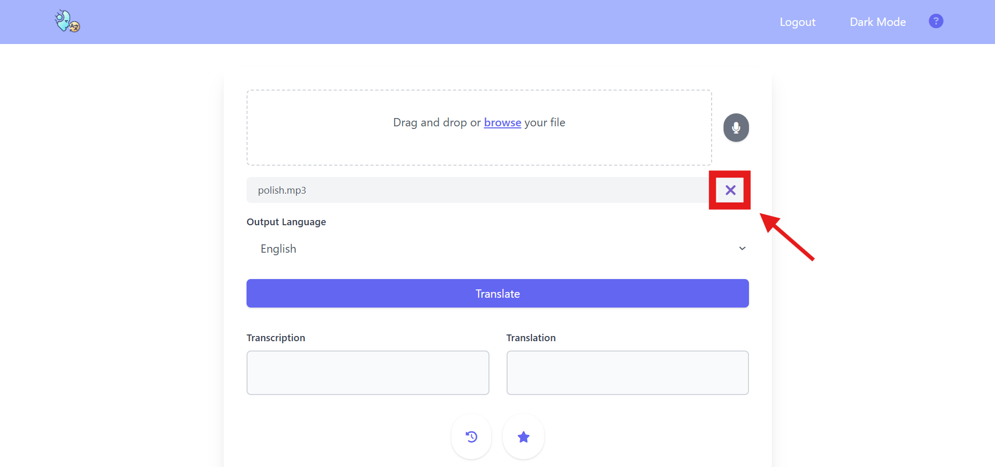

1. If you would like to remove an audio file, you can simply click on the “X” as indicated above in the red box. This will remove the file from our application and allow you to add a new audio file.

## Language Selection

[view gif](https://github.com/htmw/2024F-Bytes/raw/main/Images/select.gif)

1. To translate your audio into a different language, select the drop-down indicated under the “Output Language” section. SpeakEZ has many different language selections such as English, Spanish, German, etc.

## Transcribe

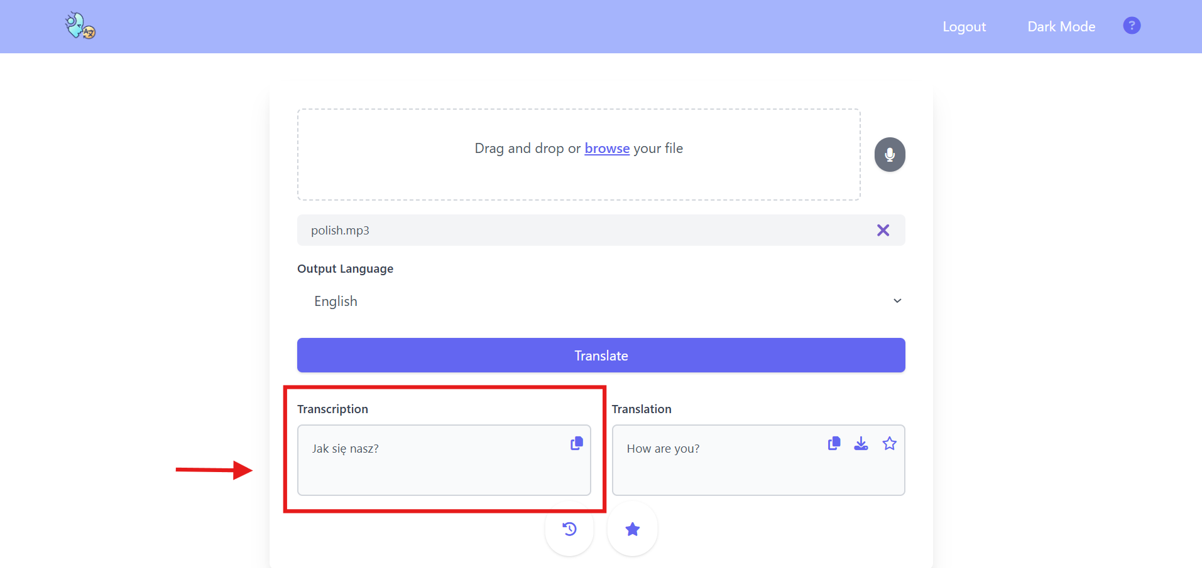

1. If you do not select a language to translate your audio, your audio will automatically be transcribed into the original inputted language. The application will also translate your audio into English.

## Translate

1. Once you have selected a language to translate your audio into, click on the “Translate” button indicated in the figure above and your audio will be translated into your selected language as shown in the red box.

## History

[view gif](https://github.com/htmw/2024F-Bytes/raw/main/Images/history.gif)

1. To access your previous translations, select the History Icon on the bottom of the page.

## Clear History

[view gif](https://github.com/htmw/2024F-Bytes/raw/main/Images/clearHistory.gif)

1. To clear your past Translations from your history section, select the “Clear History” button indicated in the Figure above.

## Favorite

[view gif](https://github.com/htmw/2024F-Bytes/raw/main/Images/Favorites.gif)

1. To indicate that a translation is important to you, you can mark it as a “Favorite”. Simply select the star icon and it will be marked as Favorite. You can also mark your historical translations as Favorite shown in the gif above. To access your Favorite translations, select the Star icon below.

## Remove Favorite

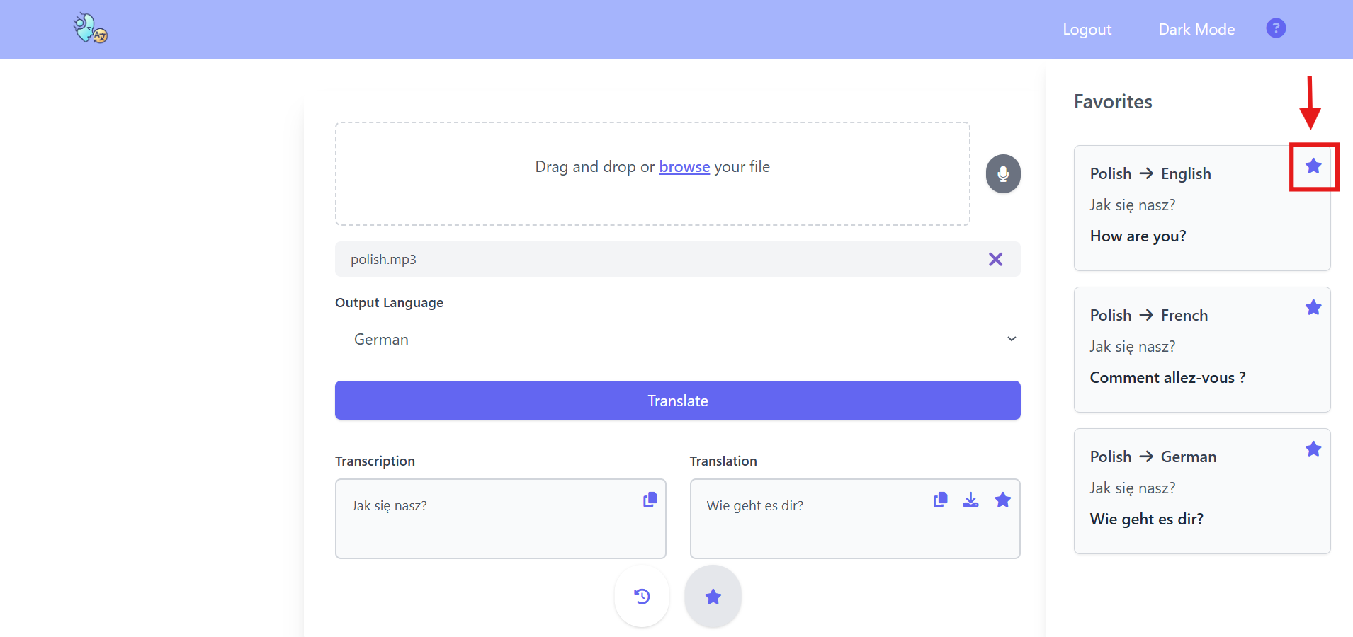

1. To remove a translation from your Favorite section, click on the star icon indicated above and your translation will be removed from that section.

## Help Icon

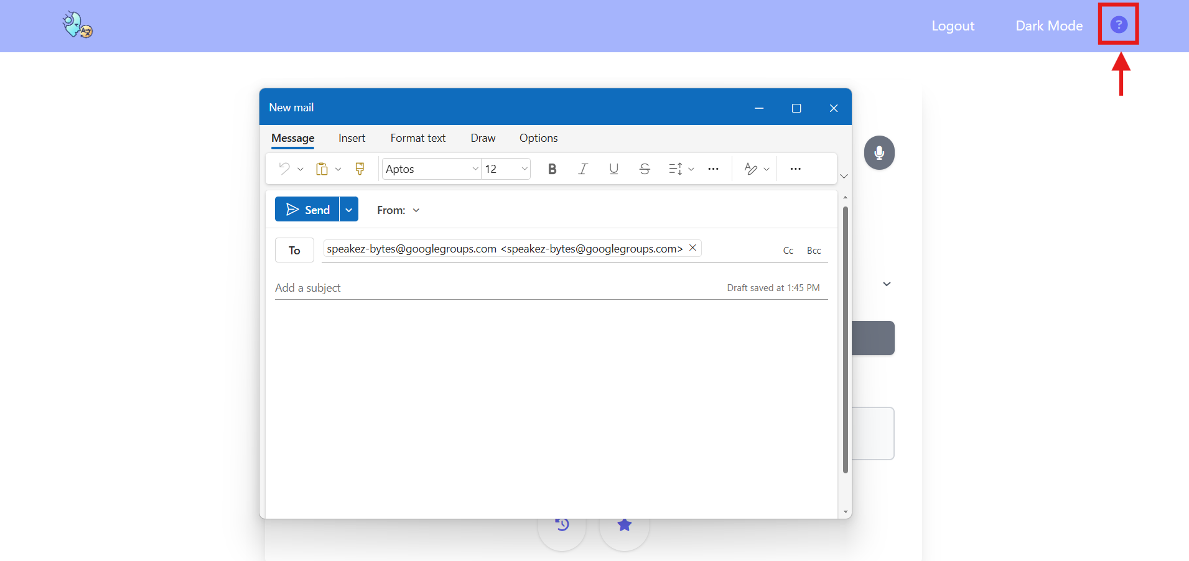

1. Should you have any queries or feedback, you can reach out to us by selecting the Query Icon indicated by the red box. Once you click the icon, you will be redirected to your email account, where you will be able to reach out to our customer service.

## Dark Mode

[view gif](https://github.com/htmw/2024F-Bytes/raw/main/Images/darkmode.gif)

1. To change your screen’s theme from Dark to Light mode, please click on the “Dark Mode” and “Light Mode” selections in the top right header.

## Logout

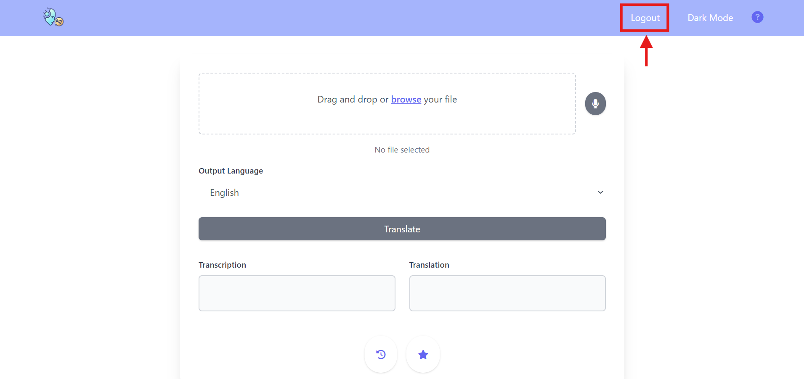

1. To log out of your account, please select the “Logout” Option in the top right header, shown in the figure above.

## SpeakEZ Icon

[view gif](https://github.com/htmw/2024F-Bytes/raw/main/Images/speakezicon.gif)

1. Suppose you do not wish to log in to your account and would like to use SpeakEZ transcription and translation function, select the SpeakEZ icon located on the top left to redirect the page for translation.